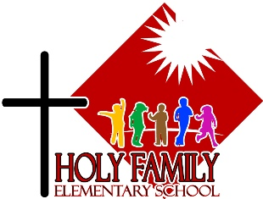

HOLY FAMILY ELEMENTARY SCHOOL
55 Wann Road
Whitehorse, Yukon Y1A 5X4
Tel: 867-667-3500
Fax: 867-667-3502
Principal: Maria Gray
Vice-Principal: Patti Oxford

Holy Family Elementary School Fees for 2022-23

Welcome to a new school year
Below is an explanation of our annual fees, followed by a form you will return with your payment.

- Religious Education Fee: $25.00 Individual or $45.00 Family (Cheque is preferred)
- Student Agenda Fee: $10.00 per student – except grade 1
- School Supplies Fee: $100.00 per student -- except grade 6 for this 22-23 year

The religious education fee enables us to provide a distinctive, faith-based education through the integration of Catholic beliefs and values in all learning experiences.

The school agenda is a communication tool that passes information back and forth between home and school. It contains school guidelines and parent information concerning aspects of student life.

We are moving to a school supplies fee (rather than shopping lists); see website for more details.

All fees are due and payable by cash or cheque to Holy Family Elementary School
(Please make sure to put your child’s name on the cheque.)

- Religious Education Fee - $25 Individual or $45 Family (Please check & list students)

____Individual Fee: $25.00

Name:____________________________ Grade:______ School:______________________

____Family Fee: $45.00 (Please list out all students, grade & Catholic school attending) (please return only 1 form and 1 cheque to school per family)

Name:__________________________ Grade_______ School:____________________________
Name:__________________________ Grade_______ School:____________________________
Name:__________________________ Grade_______ School:____________________________
Name:__________________________ Grade_______ School:____________________________

- _____QTY of Agenda(s) x $10.00 = $ __________ (except gr. 1)

- _____ QTY School supplies fee X $100.00 = $____________

Please tally your total fees:

Total Fees:$_____________________ cash or cheque made payable to Holy Family Elementary.

Please make sure to put your child’s name on the cheque or cash envelope.

