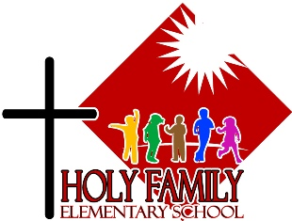

Holy Family News
January 2024

Principal’s Message:
Happy New Year : )
As a global church, we have just celebrated Christmas and Epiphany!
Epiphany is celebrated 12 days after Christmas, on January 6th, and is the time we remember the three wise men visiting the baby Jesus with special gifts.
The Magi set out; and there, ahead of them, went the star that they had seen at its rising, until it stopped over the place where the child was. When they saw that the star had stopped, they were overwhelmed with joy. On entering the house, they saw the child with Mary his Mother; and they knelt down and paid him homage. They offered him gifts of gold, frankincense, and myrrh.
- A reading from the gospel of Matthew
God of all time and space, with Epiphany joy we praise you for the year gone by and for the year we have begun.
May this school be filled with kindness to one another, with hospitality to guests and abundant care for all who gather here.
We are grateful for all the gifts that we share with one another.
Teach us to use our gifts with wisdom so that we may show your love through what we do.
We make this prayer in the name of Jesus, the Prince of Peace.
Amen.
Ms. Gray

House Keeping:

- Morning supervision begins at 8:15. There is no supervision for children before 8:15am. School ends at 3:05 and there is supervision outside until 3:25
- Better to Know (sexual health curriculum) Parent information night is on January 18th at 7pm in the school Library and on zoom.
- Please call or email the school to inform us of your child’s absence.
667-3500; hfes@yukon.ca
- Please dress you children for the weather conditions. We go outside often, even when it is cold.
- Students are not permitted to use cell phones on school grounds
- Toys are not permitted at school (pokemon, UNO cards included)
- Dogs(or any other pets) are not permitted on school grounds. We have severe allergies to pet dander.
- We are a nut and scent free building due to allergies

Cold Weather Policy:

- Up to -29 Degrees Celsius, children will go out for recess
- -30 to -35 Degrees Celsius, children will go out for 10 minutes (the students will go out for the 15 minute morning recess because of transition time)
- -35 to -39 Degrees Celsius, children will walk around the school (once for primary, twice for intermediate) and then go inside
- -40 Degrees Celsius and colder, children will stay inside for recess. (classroom teachers are welcome to take their kids out during the day for a quick walk around the school if they choose to)

School Council Update:

Welcome back! We hope you had a wonderful Christmas break.

Here are a few highlights from the ongoings of your School Council

-canvas window panels have been installed around the outdoor classroom
-Youth Investment Fund has awarded us $1500 towards our Spelling Bee scheduled for late April
- we're actively advocating for more Teachers On Call to help our staffing needs at Holy Family
-we're applying to the Crime Prevention Victim Services Trust Fund with the hope of being able to offer another Stay Safe Course and Babysitting Course
-we continue to advocate for our students riding the bus via our representative on the Busing Committee
- we represent Holy Family at the Catholic Education Association of Yukon

Our next meeting is scheduled for Monday February 5 at 7pm in the school library. Parents are always welcome.

Wishing you all the best in 2024,
Your School Council

Fundraising Updates:

-HFES La Cara Tacos fundraiser $230.00 for the school.

-Gr. 6/7 bake sale fundraiser for Development and Peace $552.80.

-Mary House giving tree. Many socks, hats, gloves, feminine hygiene products and Tim Horton gift cards were donated.

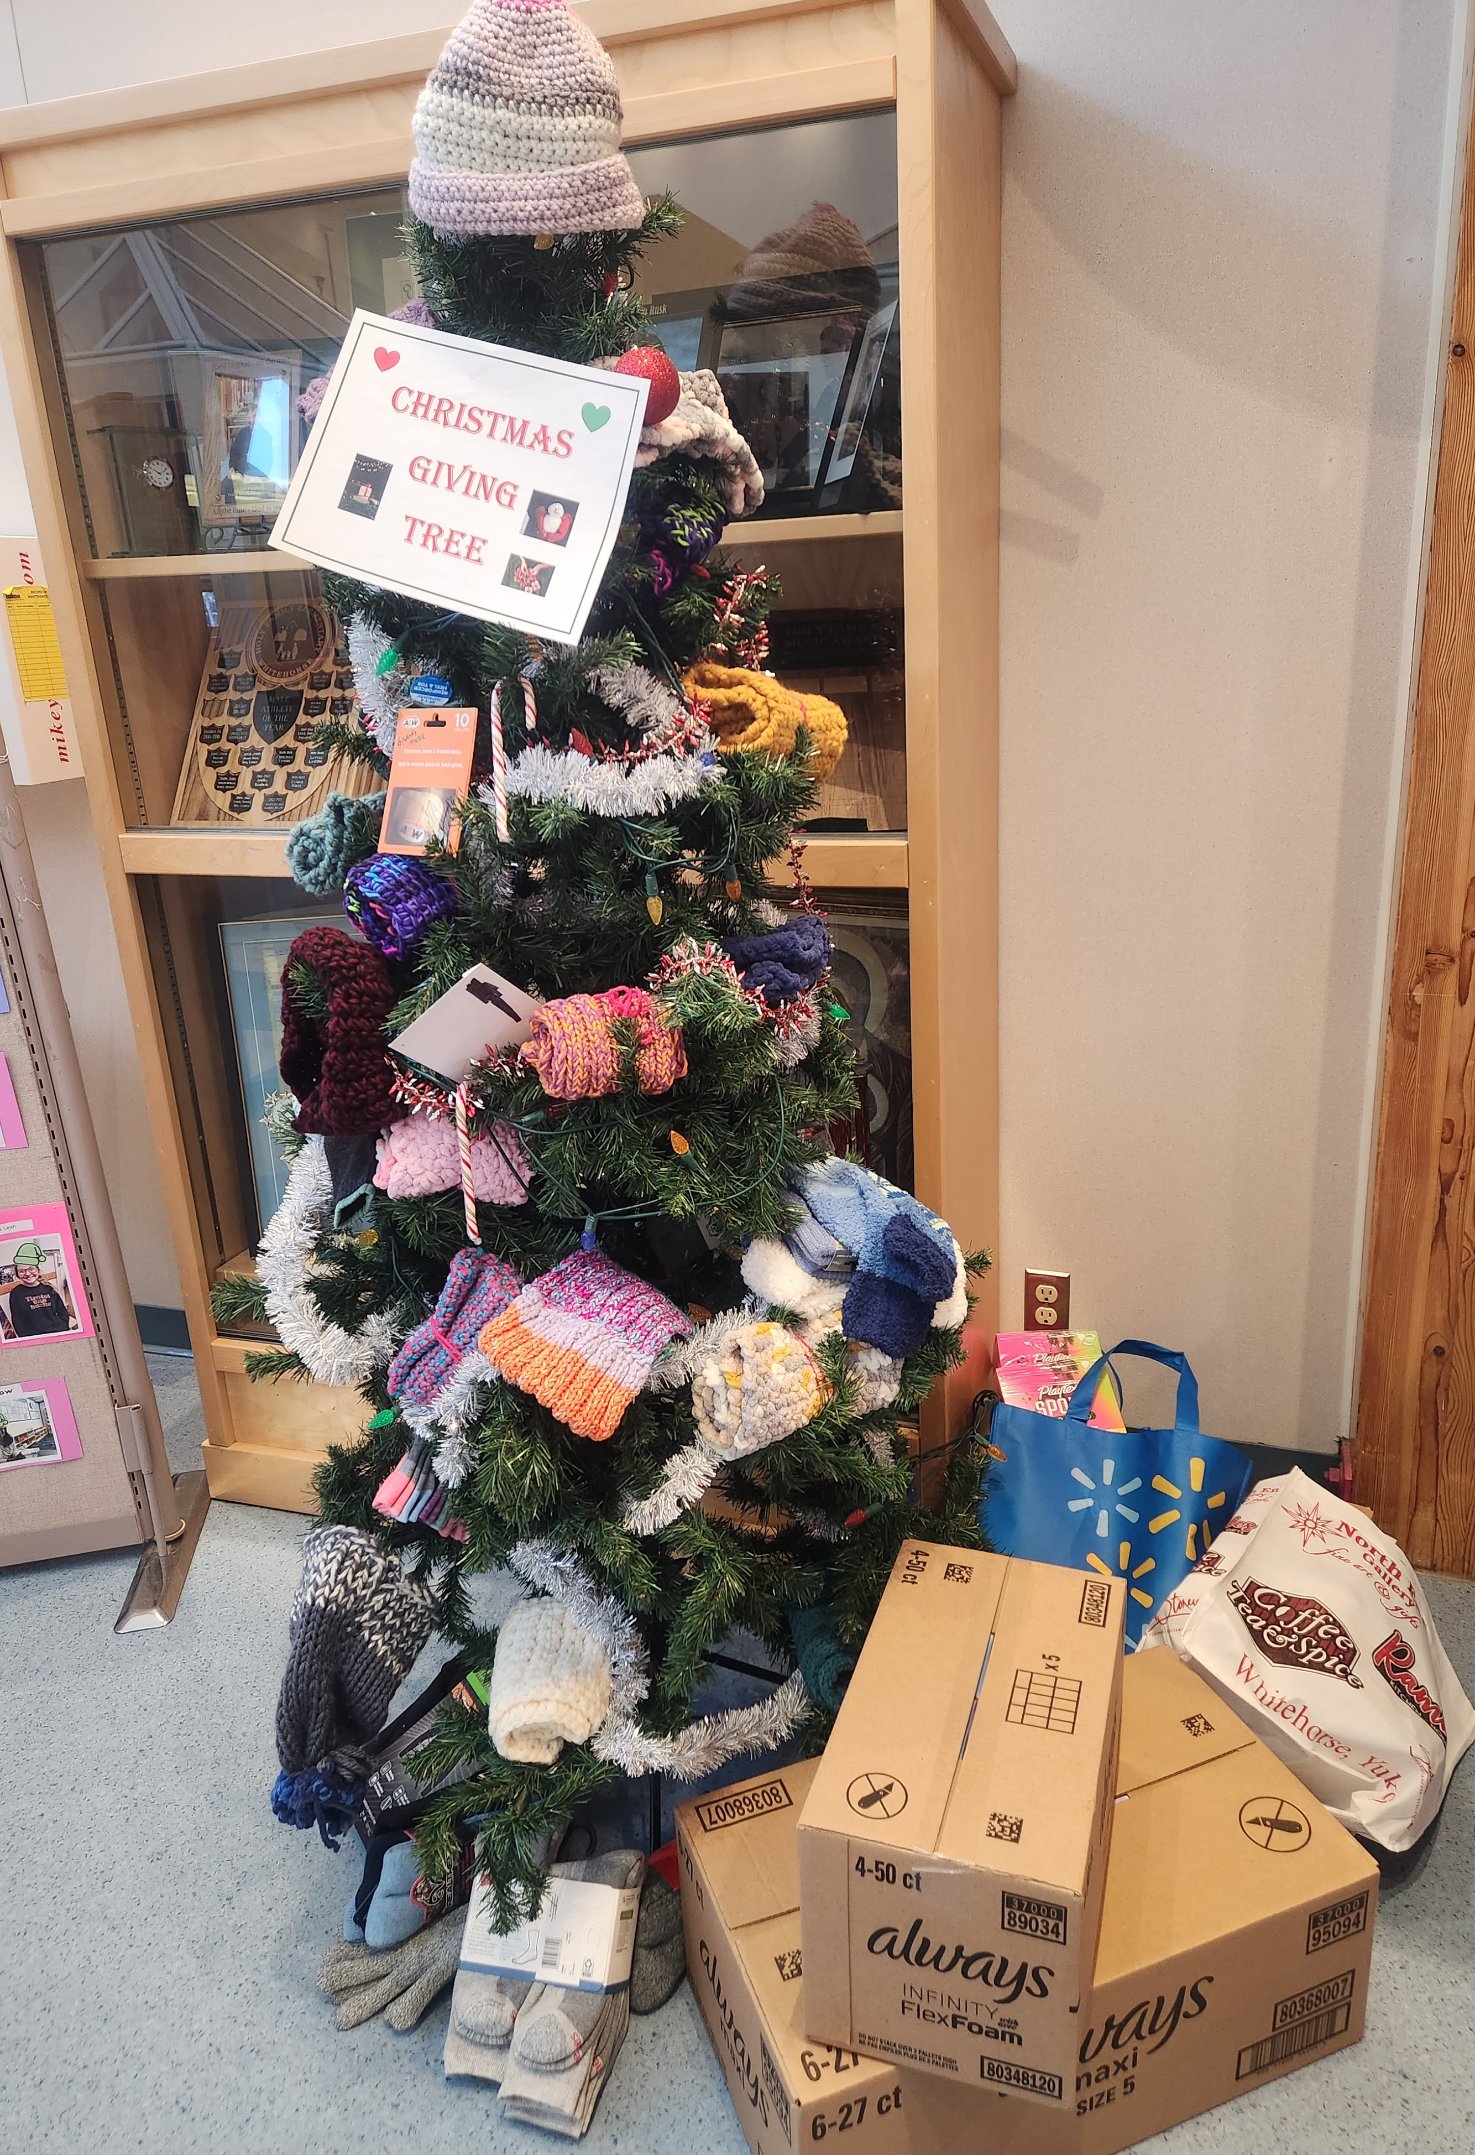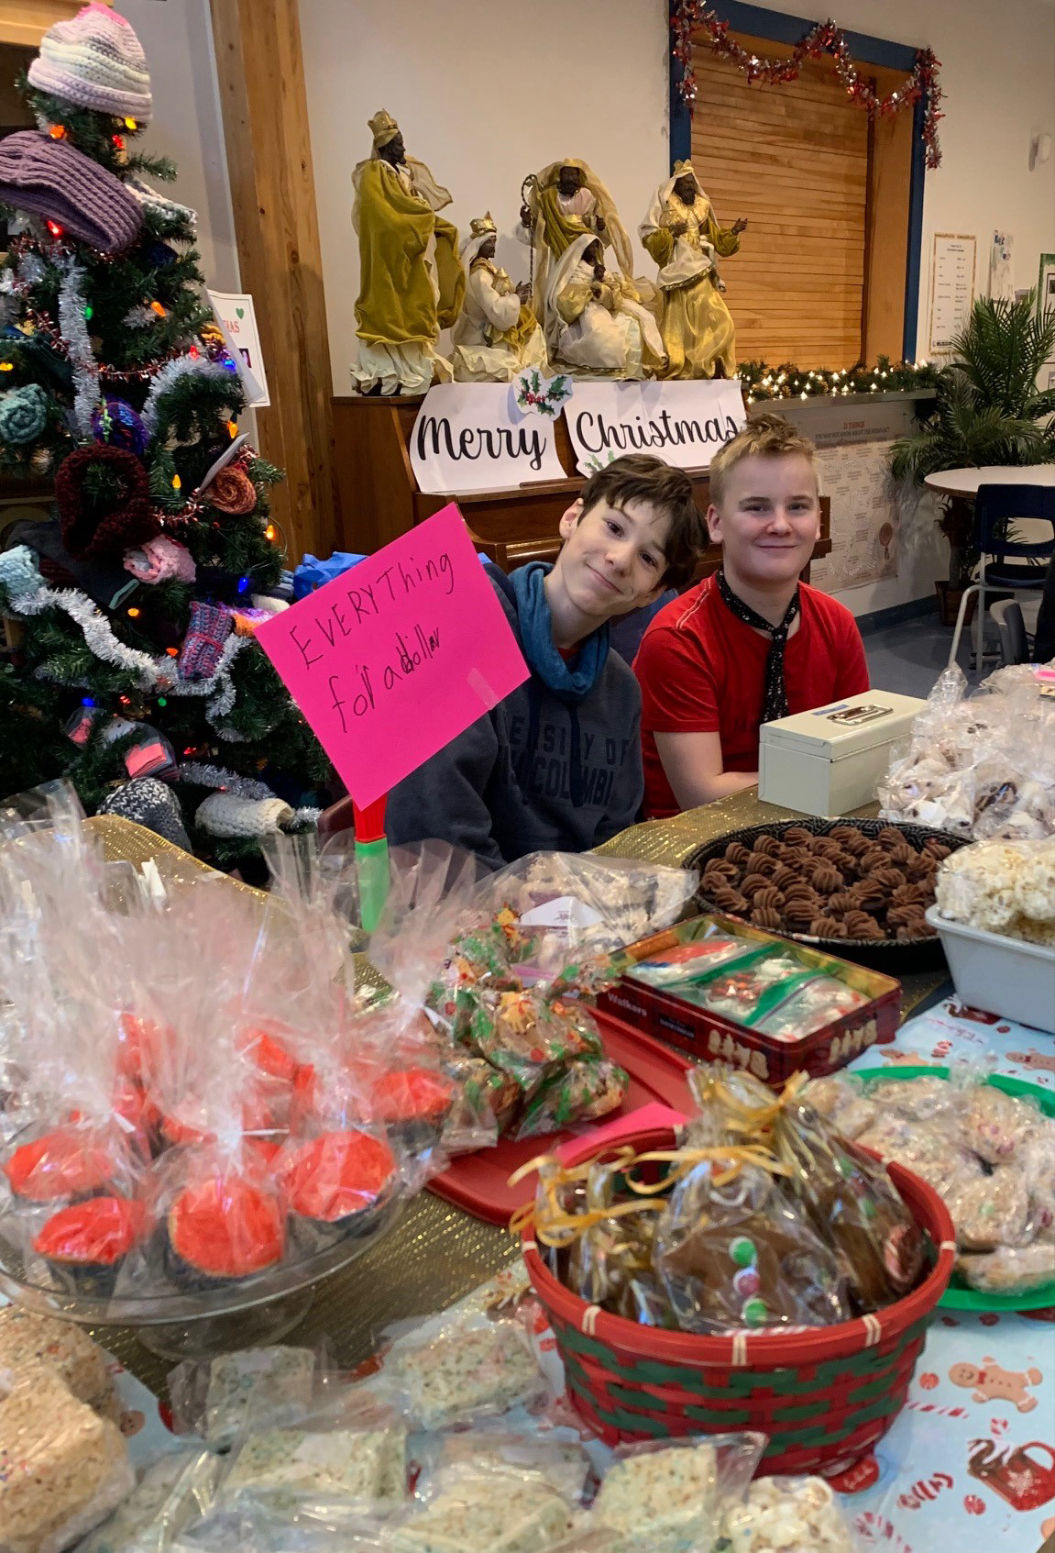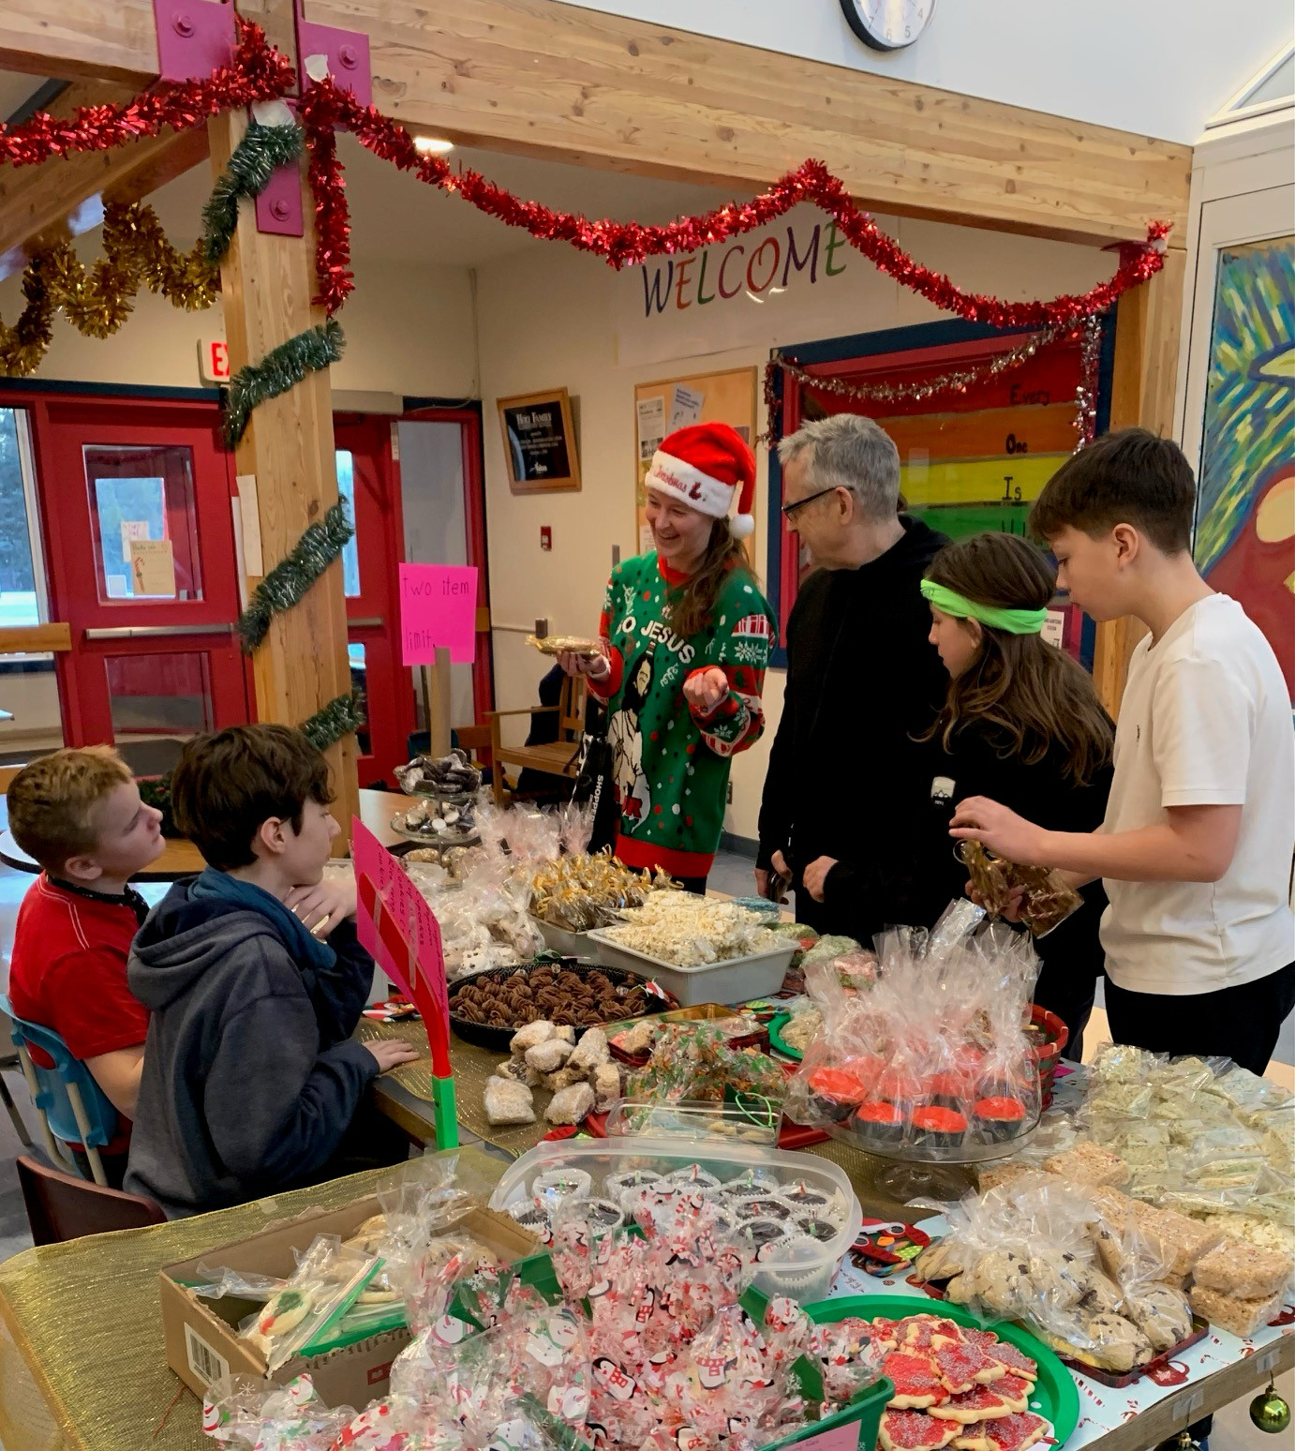
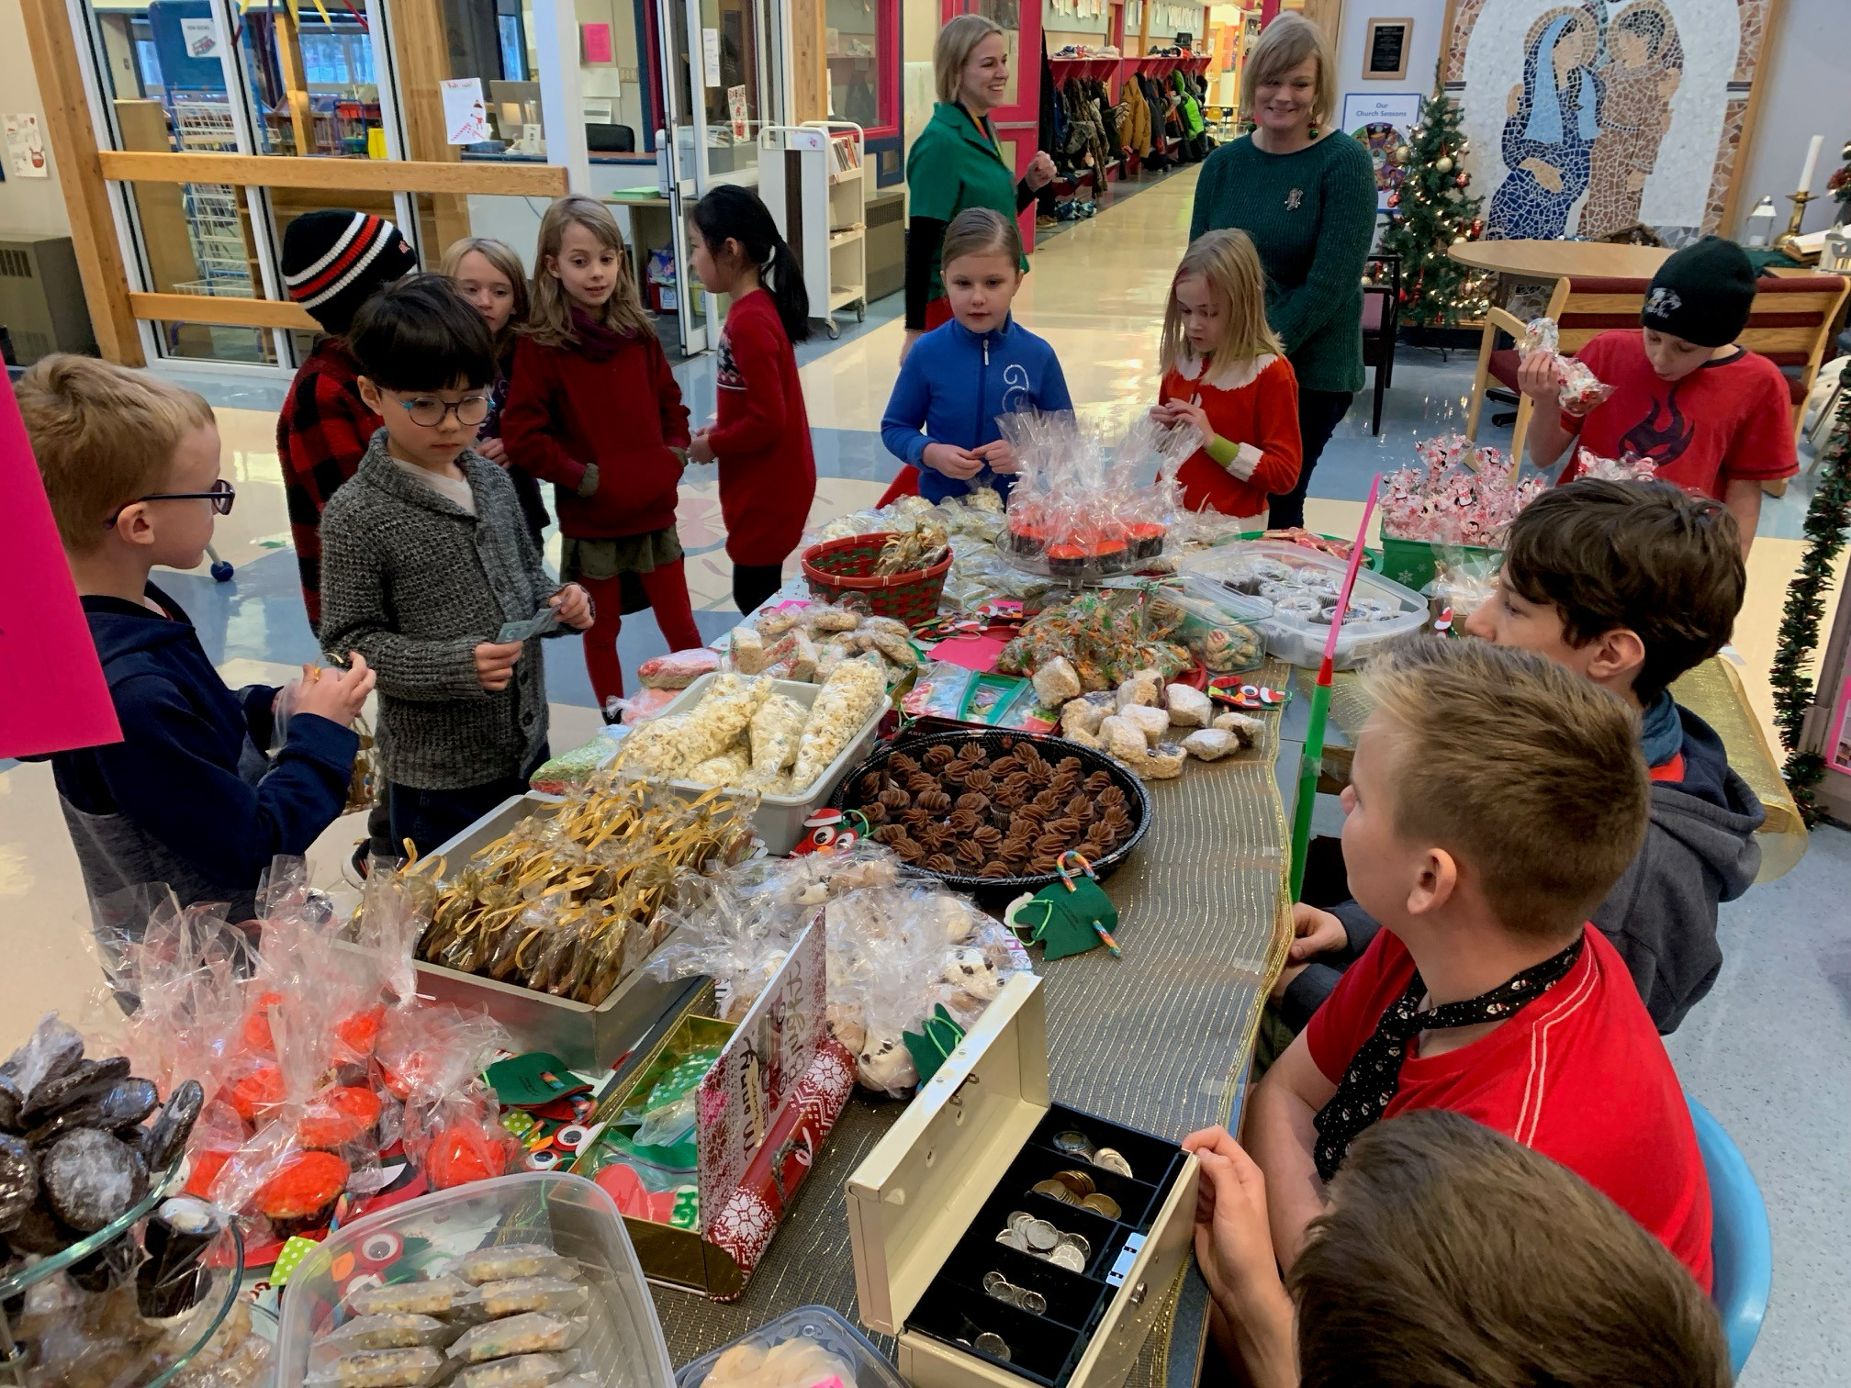
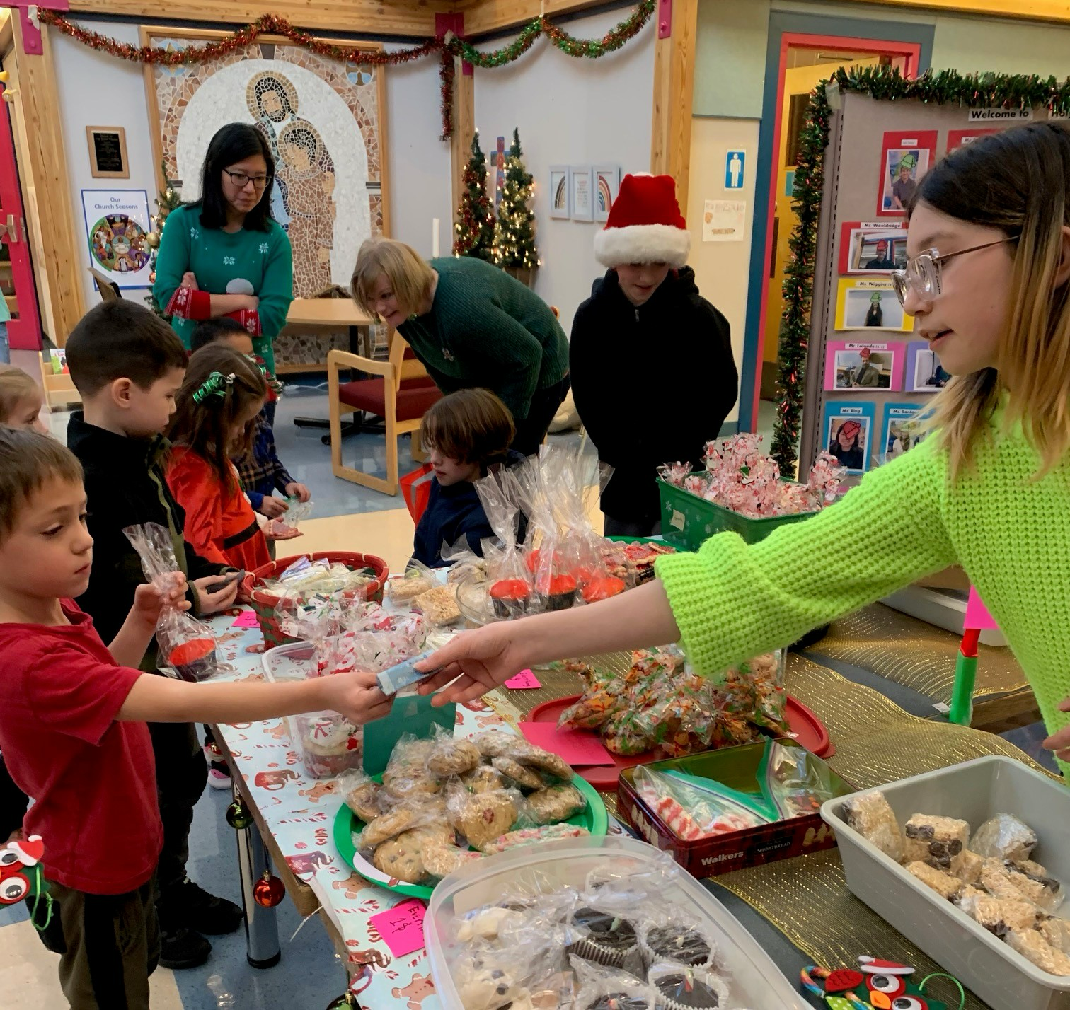

JANUARY 2024

Sunday | Monday | Tuesday | Wednesday | Thursday | Friday | Saturday
 | 1 Christmas Break | 2 Christmas Break | 3 Christmas Break | 4 Christmas Break | 5 Christmas Break | 6
7 | 8 FIRST DAY BACK AT SCHOOL  School Council Meeting 7pm | 9 | 10 Epiphany liturgy (in class) | 11 | 12 | 13
14 | 15 | 16 | 17 | 18 “Better to Know” Parent Night 7pm (in the Library and on zoom) | 19 PD DAY  NO SCHOOL | 20
21 | 22 | 23 | 24 | 25 | 26 | 27
28 | 29 | 30 | 31

FEBRUARY 2024

Sunday | Monday | Tuesday | Wednesday | Thursday | Friday | Saturday
 |  |  |  | 1 | 2 | 3
4 | 5 School Council Meeting 7pm  Student Led Conferences | 6 | 7 Polar Games grade 6 | 8 Polar Games Grade 6 | 9 | 10
11 | 12 | 13 Shrove Tuesday  PANCAKE BREAKFAST (for students) | 14 Ash Wednesday  Liturgy 2:15pm | 15 | 16 | 17
18  Lent begins | 19 | 20 | 21 | 22 | 23 Heritage Day – NO SCHOOL | 24
25 | 26 | 27 | 28 | 29

